Paper title [X Paper Title]
First name/s Last name/sª, First name/s Last name/s^{b} LEAVE BLANK FOR INITIAL SUBMISSION
ªAffiliation name LEAVE BLANK FOR INITIAL SUBMISSION
^{b}Affiliation name LEAVE BLANK FOR INITIAL SUBMISSION
*Corresponding author e-mail: LEAVE BLANK FOR INITIAL SUBMISSION
https://doi.org/10.21606/drs.2024.XXX LEAVE BLANK FOR INITIAL SUBMISSION
Abstract: These guidelines provide instructions to format your full visual paper for DRS2024. The title, authors, abstract, keywords, and references should follow the written paper's predefined styles. The Abstract for a visual paper should be written, not drawn, and no more than 150 words and one paragraph only. Avoid quotation and citing references in your abstract.
If you are handwriting the headings and figures in the body of the paper, they should be easily readable and sized, like the predefined formatting styles of the written format. Please limit your visual paper to 15 pages vertically formatted, using the borders of this template. Examples of different visual content have been inserted in section 3.2 below. The file size is limited to less than 50 Mb.
The written paper styles are as follows. Please write directly into the template or copy your finished text into it, choosing ‘match destination formatting’ if you are going to use type. Please use the predefined formatting styles instead of applying your individual settings. These styles are preceded with ‘X’, such as X Paper Title, X Abstract or X Paragraph. Do not change the predefined formatting settings in this document as the aim is to produce the conference proceedings, the conference programme, and other important information, using a consistent style. The Abstract for a visual paper should be written, not drawn, and no more than 150 words and one paragraph only. Avoid quotation and citing references in your abstract. Submit your paper to the conference system at https://www.conftool.pro/drs2024/.
Keywords: keyword 1; keyword 2; keyword 3; maximum 4 keywords [the keywords are formatted as X Keywords]

1. Introduction [this is formatted as X Heading 1]
Visual communication is a fundamental language for design and designers. It helps us analyze, organize, communicate, reflect, negotiate, persuade, explain, discuss, and present design concepts, products, experiences, and services. Visual papers employ sketched or drawn images to communicate the primary information, while text plays a supporting role. Visual paper content should consist of traditional research issues: a research question and an outcome, a claim and an argument, and proper contextualization through literature.
Visual papers provide a much-needed peer-reviewed outlet for authors whose primary mode of thinking, teaching, and research is visual. Visual papers provide unique knowledge that is difficult to communicate and understand using words. We are excited to endorse visual papers for our conference track and look forward to experiencing your research visually.
Two examples of visual papers published through a DRS conference can be found here:
https://dl.designresearchsociety.org/learnxdesign/learnxdesign2021/visualpapers/

All visual paper submissions for DRS2024 will be selected through a doubly-anonymous review process conducted by an international review panel. Please read these guidelines all the way through before you submit your full paper as they will save you valuable time. Please ensure that your paper has been proofread, to enable the reviewing process to run more smoothly. [X Paragraph]
You should submit your initial paper in PDF format using this template. Your paper should be up to 15 pages in length excluding abstract and references. DRS2024 is a general design research conference and a wide variety of work and projects will be reported. Irrespective of the range and stage of your research, we expect high standards of scholarship and clarity in terms of establishing context, explicating methods of inquiry, and reporting results. Your paper may also be more experimental (or pictorial) in nature to present design research that might, for example, include significant use of visual material to communicate the work alongside textual narrative, or even time-based or networked material. It is important that, whatever media are used, a coherent narrative is developed and the purpose of the media used is explained. This template format, modified as appropriate, should still form the basis of such a submission, with reference to large media files made through external weblinks (see Section 3.2 and 3.3).
All accepted papers will be published in the online proceedings which will have an ISSN and be made accessible from the DRS Digital Library https://dl.designresearchsociety.org. Papers will be given a DOI reference to ensure they are picked up in scholarly web-searches. We aim to produce conference proceedings of a professional and consistent quality, and appreciate your careful following of the instructions outlined in this guide.
This template document itself uses the same formatting as required for the Conference so your paper should appear visually very similar. You can access template styles for Titles, paragraphs, and other styles directly from the Quick Style Menu that is part of the Home Menu in Word. Please do not change the predefined formatting settings in this document (such as paper size, orientation, margins, typeface, size, indents, spacing, headings, etc.).

2. How your paper will be reviewed
Peer review is central to ensuring both the quality of papers published in the proceedings and the quality of material that is presented at the conference. Your paper will be reviewed anonymously by two people and managed by the Programme Committee. Reviewers will be asked to construct their reviews in the following way and you should keep this in mind when writing and proofreading your paper:
- Reviewers will be asked to start their review by summarising the paper in a few sentences. This helps the committee remember what the paper was about and reassures authors that their paper has been understood; [X Bullet list]
- Reviewers should state whether the paper is relevant to the conference and mention any particular conference themes that they think it fits well with (see https://www.drs2024.org/ for the conference themes);
- Reviewers will then be asked to comment on the strengths of the paper and also its main weaknesses, constructively suggest how the paper might be improved, and list any minor errors that need correction;
- It will be emphasised to reviewers that the review is a piece of communication (both to the authors and the review chair) and it should be clearly written, well-structured, factual and polite.
Reviewers will score your paper on a scale of 1 to 10 and recommend one of three outcomes:
- Accept; [X Numbered list]
- Revise;
- Reject.
As an author you will be informed of the outcome but will not be notified of each reviewer’s score. On receiving your outcome notification, you will have an opportunity to provide feedback on the quality of the reviews you have had.

3. Completing your paper submission

3.1 General Guidelines [X Heading 2]
The sections of your paper should be numbered, though not go deeper than one sub-section (i.e. Section 2.1 is fine but Section 2.2.1 is not).
For lists of material you can either use a bulleted list:
- Design; [X Bullet list]
- Research;
- Society.
Or a numbered list:
- Hybrid; [X Numbered list]
- Boston;
- Massachusetts.
Tables should be formatted as Table 1 (below): left justified text for first column and centred columns thereafter, if possible (see Table 1). Only horizontal table grid lines should be used. Add one empty paragraph of the [X Paragraph] style following a table. For accessibility purposes (e.g. screen readers), it is helpful to mark the header row of a table as a header row using Word’s Table Design feature (see this useful ACM SIGCHI guide https://tinyurl.com/chiaccessible).
Table 1 Table layout. Captions for tables are placed above. [X Table title].
Table Rows [X Table] | Cell one | Cell two
Second Row | 1 | 2
Third Row | 2 | 3
Fourth Row | 4 | 5

3.2 Use of Visual Materials
Please think carefully about the presentation of your visual materials. As the proceedings will be published in digital form, you have the opportunity to include good-quality colour images or other media files that help to present your research and its context. Images should relate to the body text with the indication (Figure 1), “as shown in Figure 1” or similar. The image should be below and as close as possible to the related text. If images or image montages are being used more extensively to create a more pictorial narrative, individual numbering may not be necessary. If an image is not yours, please acknowledge/cite its source following the caption and ensure you have the rights to reproduce it. Note that DRS 2024 papers will be published open-access under a Creative Commons Attribution-NonCommercial 4.0 International Licence (https://creativecommons.org/licenses/by-nc/4.0/).
Where possible please make images:
- Large enough to be seen clearly;
- Of good resolution (200dpi);
- Optimised in terms of contrast etc.;
- Sized so that your entire file ideally does not exceed 5 MB;
- Cropped appropriately.
- To improve the accessibility of your paper, please use the Alt-text function in Word to provide a useful description of each image (not just repeating the caption). See https://tinyurl.com/chiaccessible for some valuable guidance produced by ACM SIGCHI.
If you are using diagrams, infographics, or other schematics please ensure that:
- You present information clearly;
- You use a clear font;
- All text is legible.
- Useful Alt-text descriptions are present, as with other images.
After you have inserted an image into your document, select it and use the style named [X Picture] (see Figure 1). Images are followed by a caption with figures numbered sequentially – Figure 1, Figure 2, etc., as shown in Figure 1.
Figure 1 Captions are placed under the pictures. Ensure that your caption adequately describes what you want your reader to see in the picture, highlighting any areas that they should focus on or relationships that you might want them to see. [X Caption].
Find below, four different examples of visual paper body content. Notice the different uses of type style and size, colour, borders,

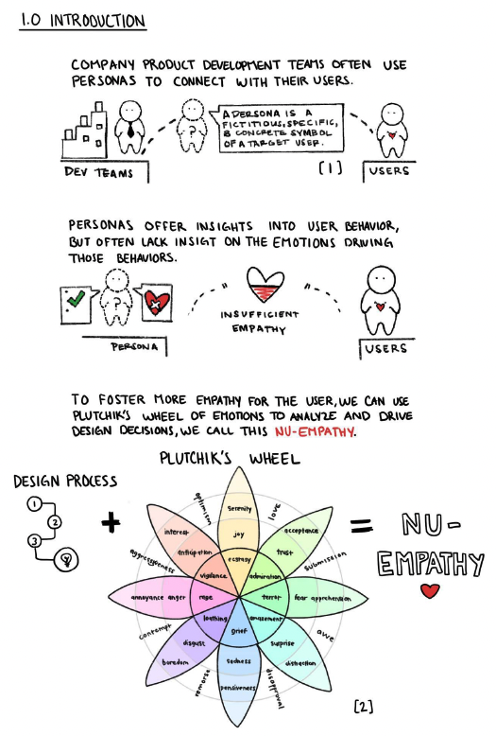
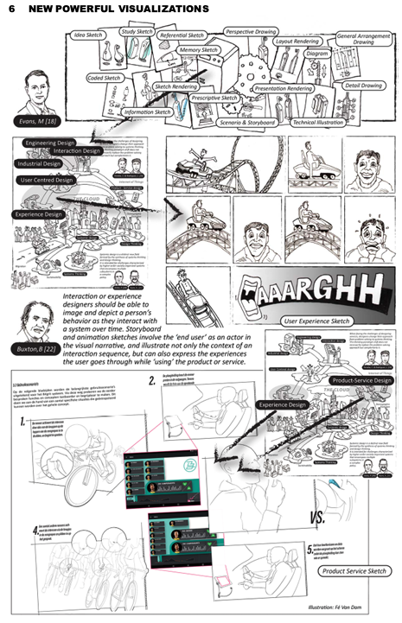
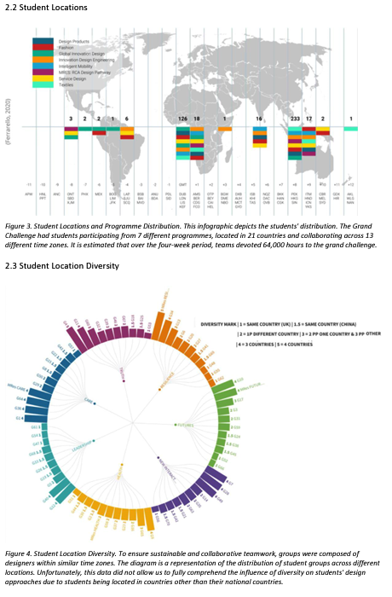
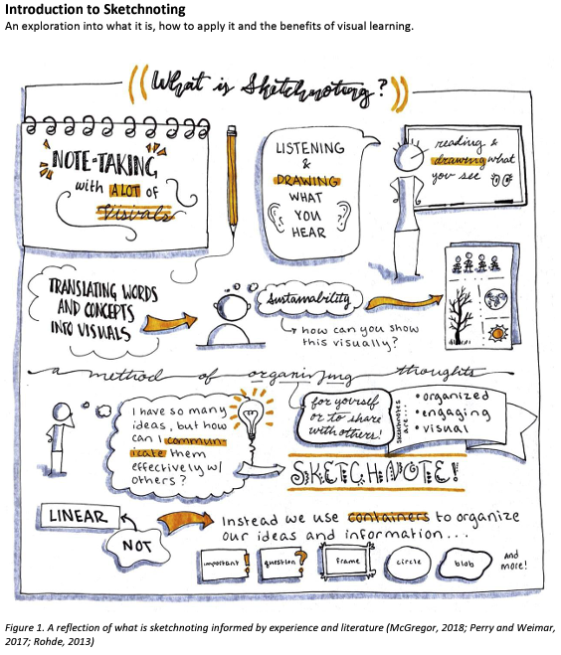

3.3 Quoting and Referencing
Short quotations within the text should be marked with double quotation marks—for example:
Noel proposes a different stance for design education when she notes how “[t]hese curricula separate design education from innovation or consumption, and instead focus on identity, agency, culture, and building thinking skills” (Noel, 2020, p.5).
Longer quotations of more than 40 words should be formatted as below, again within double quotation marks:
“This research found that the design studio is not a universal, neutral, or a timeless approach to design education. It was developed by European schools and, thus, embodies European values and definitions of what design is and what a designer could be. When appropriated by the Global South, these values and definitions should be taken with a good grain of salt. Educators are left with non-trivial questions such as: what does interaction design mean in my locality? Which kind of designer do we want to train? Which kind of design autonomy should we nurture?” (van Amstel & Gonzatto, 2020, p. 17) [X Long quotation]
Referencing and in-text citation should follow the APA 7, Author-date, Style Guide that is explained in this resource from Purdue University: https://tinyurl.com/purdueposter
To allow doubly-anonymous peer review it is very important that you do not include authors’ names or institutional details in the review version of the paper; you can add these later if your paper is accepted.
Doubly-anonymous reviewing also means that you need to anonymise any reference to your own publications. Citations of your own work in the main text should take the form (Author, 2024). References to your own work should be presented at the end of the reference list in the following way (this is for a journal article, for example, but applies equally for other forms of publication):
Author (2015). Journal article.
Links to web addresses over 25 characters in length (either in the main text or in the references) should ideally be shortened using a URL shortener for purposes of neatness.
If you use reference management software such as EndNote or Word Citation & Bibliography, make sure that you submit your paper with the fields unlinked to your bibliographical database.

4. Submitting your paper
In preparing your paper for DRS2024 please note the following:
- We are aiming to produce high-quality conference proceedings. Please follow as closely as possible this template structure and associated style guidelines;
- Your initial full paper submission should be in PDF format. Should your paper be accepted, your final submission will be in Word and PDF formats to allow us to prepare the conference proceedings;
- Please register an account and submit your full paper at: https://www.conftool.pro/drs2024/
- Please make sure you can answer ‘yes’ to all the following questions:
- Is the context of the work clearly described?
- Is the contribution that is made clearly stated?
- Does the paper conform to this paper template?
- Has the paper been independently proof-read?
When you submit your paper, you will be prompted to select a number of topic areas that best fit your research. This will allow the DRS2024 Programme Committee to allocate suitable reviewers to your paper. The Programme Committee will allocate reviewers and oversee the process to ensure consistency across all submissions.
Acknowledgements: This section is optional. You can use this section to acknowledge support you have had for your research from your colleagues, students’ participation, internal or external partners’ contribution or funding bodies, etc. [Leave blank for initial submission] [X Acknowledgments]

5. References
Ahmed, S. (2019). What’s the Use? On the Uses of Use. Duke University Press. [X Reference list]
Boess, S. (2016). DRS2014: Design’s big debates: Design Research Society’s Seventh Biennial International Conference, Umeå, Sweden, June 16–19, 2014. (Conference review). Design Issues, 32(2), 91–94. https://doi.org/10.1162/DESI_r_00385
Bosch Gomez, S., & Qazi, H. (2019). The Disconnect Between Design Practice and Political Interests: The Need for a Long-Term Political Engagement as Design Practice. Proceedings of ADIM 2019: Academy for Design Innovation Management, London, June 19–21, 2019. https://doi.org/10.33114/adim.2019.01.185
Cortés-Rico, L., Patarroyo, J., Pérez-Bustos, T., & Sánchez-Aldana, E. (2020). How can digital textiles embody testimonies of reconciliation?. Proceedings of PDC ’20: 16th Participatory Design Conference 2020—Participation(s) Otherwise, Vol. 2, Manizales, Colombia, June 15–20, 2020. https://doi.org/10.1145/3384772.3385137
Lin, R. T. (2006). 訴說故事，營造情境--文化創意設計的情境故事 [Scenario and story-telling approach in cross cultural design]. 藝術欣賞 [Art Appreciation], 2(5), 4-10. [If the original article is not in English language, the title should be translated and inserted in parentheses, as indicated here.]
Lloyd, P. (2017). From design methods to future-focused thinking: 50 years of design research. Design Studies, 48(C), A1-A8. https://doi.org/10.1016/j.destud.2016.12.004
Noel, L. (2020). Envisioning a pluriversal design education. In Leitão, R., Noel, L., & Murphy, L. (eds.), Proceedings of Pivot 2020: Designing a World of Many Centers: DRS Pluriversal Design SIG Conference, June 4, 2020, held online. https://doi.org/10.21606/pluriversal.2020.021
Reddy, A., & Reimer, M. H. (2018). Platform Ethics in Technology: What Happens to the User? In Storni, C., Leahy, K., McMahon, M., Bohemia, E. & Lloyd, P. (Eds.). (2018). Proceedings of DRS2018: Catalyst, Vol. 1, 145-158. https://doi.org/10.21606/drs.2018.321
van Amstel, F.M.C., & Gonzatto, R.F. (2020). The anthropophagic studio: towards a critical pedagogy for interaction design. Digital Creativity, 31(4), 259-283. http://doi.org/10.1080/14626268.2020.1802295
Winchester, W.W., III. (2019). Engaging the Black Ethos: Afrofuturism as a Design Lens for Inclusive Technological Innovation. Journal of Futures Studies, 24(2), 55–62. http://doi.org/10.6531/JFS.201912_24(2).0007
Author (2015). Journal article.
Author (2022). Conference paper.

About the Authors:
Author 1 add an author bio that describes research interests and any other achievements in a maximum of 40 words. This description is 21 words. [Leave blank for initial submission] [X Author Bio]
Author 2 add an author bio that describes research interests and any other achievements in a maximum of 40 words. This description is 21 words. [Leave blank for initial submission]

